HELP Math 2.0 Progress Report
  - As of 20 September 2026 | Major work Gantt chart Progress measures
The project has established source preservation, a JavaScript migration factory and the modern My Lesson experience. The designated G3–G5 candidate covers 29 lessons and 1,751 active pages, with English loading and visible-rendering checks recorded on September 9 and deployment/audio verification on September 10. Work now continues on G6–G8, native text and interaction upgrades, and original-runtime and human acceptance. [1–6]
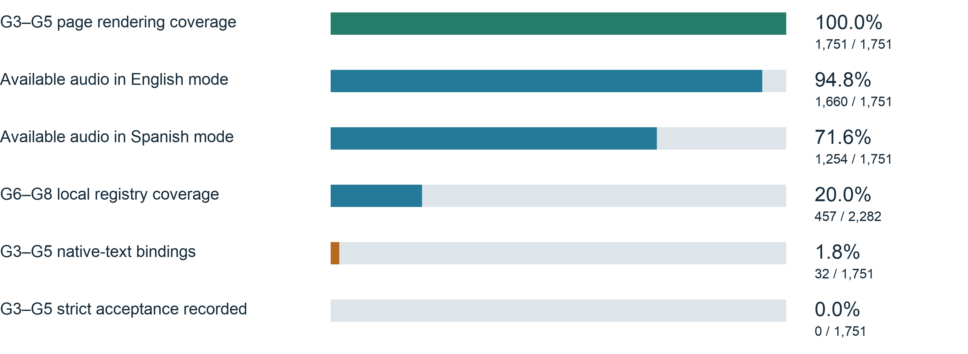
How to read these measures Each percentage uses its own defined scope. Rendering, available audio, registry membership, implementation bindings and formal acceptance are separate stages. They cannot be averaged into an overall project completion rate. Zero strict acceptance means no qualifying acceptance is recorded; it does not mean no engineering work has been completed.
Evidence dates G3–G5 rendering: Sep 9. Audio and deployment: Sep 10. G6–G8 registry count and native-text work: Sep 20. Online results refer to their recorded verification dates. [1–4]

Gantt chart of major work
Bars show documented implementation and verification periods. Their starting windows are reporting intervals, not asserted project start dates. Bar length represents elapsed reporting time, not effort or percentage complete.
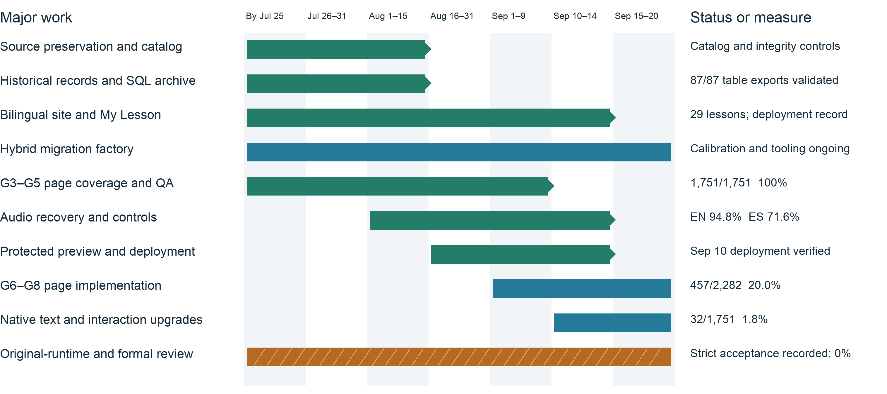
Legend Green with diamonds: a stage has a recorded result or milestone. Blue: implementation continues. Hatched amber: preparation continues while acceptance remains open. Early work is grouped under “By Jul 25”; no unapproved future deadlines are shown.
Sequence July established the source archive, workbench and pilots. August developed source governance, page scope, migration methods and the learning experience. September added the G3–G5 candidate/deployment milestone and continued expanded-course and readability work. [1–8]

Major work delivered

Traceable source assets and historical records
Original FLA, SWF, audio and XML assets now have catalogs, hashes and preservation controls. The August 2 Grade 4 transaction added 1,228 source files: 202 active-page SWFs, 143 FLAs and 883 MP3s. This established SWF source coverage for 645/645 Grade 4 active pages. Source availability remains separate from instructional behavior and audio acceptance. [5]
A private catalog was established for historical office records. Exports of all 87/87 historical SQL tables were validated, with boundaries for using curriculum, assessment and standards data. Historical personal records and credentials are excluded from the public application. Google Drive technical assets enter quarantine and are hash-matched before approved promotion. [5]

A learning experience beyond the public website
Work includes an English/Spanish website, responsive navigation, course entry and the modern My Lesson player, with source page order, navigation, Replay, progress, support tools and playback controls. The G3–G5 scope is 1,751 active pages across 29 lessons. The 29 legacy Flash course shells are preserved as history and excluded from the migration denominator. [1,5,7]

A repeatable migration and verification workflow
The workflow includes source extraction, static audits, intermediate representations, generation/cache support, renderer registration and course integration. Calibrated generation serves simpler pages; source-backed state machines and maintained manual implementations serve complex interactions. Original-runtime, fidelity, audio, human, Owner, strict-completion and publication gates remain independent. [5,7]

Batch evidence for G3–G5 and audio repairs
The September 9 candidate recorded 1,751 successful English page loads and visible renders, 654 passing unit tests, a passing production build and TypeScript check, and 2,605 resources with matching bytes and hashes. September 10 repairs added direct play/stop, volume, mute/restore and navigation cancellation, while retaining initial failures and same-candidate rechecks. [1,2]
Deployment milestone The September 10 record confirms the approved production switch and formal-domain checks, including 232 public page samples and 139 actual audio starts. Deployment does not establish formal lesson acceptance. These are dated results, not a new September 20 live-site audit. [2]

Progress percentages and remaining scope
Measure | Count and percentage | Remaining scope or boundary | Evidence date
G3 page rendering | 546 / 546 100.0% | English technical checks on the designated candidate | Sep 9
G4 page rendering | 645 / 645 100.0% | English technical checks on the designated candidate | Sep 9
G5 page rendering | 560 / 560 100.0% | English technical checks on the designated candidate | Sep 9
Available English-mode audio | 1,660 / 1,751 94.8% | 91 pages not counted as having available audio | Sep 10
Available Spanish-mode audio | 1,254 / 1,751 71.6% | 497 pages not counted as having available audio | Sep 10
G6–G8 private registry coverage | 457 / 2,282 20.0% | 1,825 pages without a matching private registry entry | Sep 20
G3–G5 native-text bindings | 32 / 1,751 1.8% | 1,719 pages without a binding for this upgrade | Sep 20
Whole-page technical passes for this upgrade | 0 / 1,751 0.0% | Implementation bindings are not technical passes | Sep 20
G3–G5 strict acceptance recorded | 0 / 1,751 0.0% | Original-runtime, audio, human and Owner evidence required | Existing matrix [6]
Audio definition Available audio means source audio can be safely bound in the relevant interface-language state; it does not mean complete narration on every page. Gaps may reflect missing recordings, conditional effects or question-binding limits. Bilingual routes do not establish complete Spanish instructional content. [1,2]
Registry definition The September 20 count matches animation IDs in the local private registry against all 2,282 active pages across 44 G6–G8 lessons. Other registry keys are excluded. This is a membership count, not a rerun of all page tests or whole-course acceptance. [3]
Acceptance definition The older main-workspace matrix records 426 registrations; the later 1,751-page candidate is a different snapshot. Candidate coverage uses the later record, while formal acceptance remains independently open. No new complete acceptance record was established by this report. [1,6]

Work in progress and next priorities

Expanded courses and native-text upgrades
G6–G8 work includes shared modules, private renderers and modern font support. By September 20, local records reached the NMS002 Lesson 2 P037 matching activity and included 36 native-text page-binding files. Those files belong to the expanded-course worktree and are not added to the 32 G3–G5 upgrade bindings. [3,4]
The G3–G5 upgrade retains 32 implementation bindings. The G4 L3 IN009 V39 report records nine bounded checks passed and three pending. The thermometer LCD14 value/unit remains unresolved, so whole-page technical passes remain zero. IN010 work is integrating source-backed drag/drop, keyboard behavior, feedback, audio and Replay. [4]

AI tutoring and learning-data capabilities
Nova work includes course allowlists, shared server capability checks, text questions, current-frame support and speech drafts. An August 24 protected-preview record demonstrates a real G4 L3 text-only request. It does not establish other capabilities, other courses, human acceptance or production readiness. LRS, contact delivery, privacy terms and school workflows retain separate evidence requirements and have no defensible aggregate percentage. [8]
Order | Next work | Observable completion condition
1 | Resolve current source and technical blockers | Resolve IN009 LCD14; verify IN010 interaction, audio and readability on one candidate.
2 | Continue G6–G8 implementation | Bind source, registration, actual My Lesson behavior and audio evidence to the same candidate.
3 | Close bilingual audio and content gaps | Separate missing recordings, conditional effects and real defects; document listening review.
4 | Run original-runtime and human lesson review | Complete original-runtime capture, visual/behavior comparison, listening and named approvals.
5 | Verify each subsequent approved release | Check candidate identity, environment, domains, provenance, routes and rollback records.
These are suggested priorities, not approved delivery dates. Update each measure only when its own evidence passes. A project-wide percentage requires an agreed scope, weighting model and acceptance criteria.

Evidence and measurement notes
Reporting cutoff: September 20, 2026. Records belong to different worktrees, candidates and dates. An older workspace snapshot does not override a later candidate, and a deployment does not substitute for lesson acceptance.
[1] G3–G5 candidate verification | Sep 9, 2026 · controlled-preview worktree
work/controlled-preview-2026-09-09/FINAL_REVIEW_REPORT.json
[2] Audio repair and deployment milestone | Sep 10, 2026 · 00c7 worktree
output/audio-repair-20260910/PUBLIC_AUDIO_REPAIR_REPORT.json; HANDOFF_STATUS.json
[3] G6–G8 registry membership count | Sep 20, 2026 · g678-implementation worktree
packages/demos/private-current-js-registry.json; catalog/g678-page-only-release-manifest.v1.json
[4] Native-text and interaction upgrades | Sep 20, 2026 · typography and G6–G8 worktrees
work/typography-v1/g4l3-in009-v39-final-audit/REPORT.md; g4l3-in010-integration-v1/PLAN.md
[5] Source preservation and historical data | Dated project records from Jul 25 to Aug 4, 2026
AGENTS.md; PROJECT_MEMORY.md;
catalog/source-promotions/g4-active-source-promotion-2026-08-02-applied.json
[6] Independent acceptance matrix | Existing main-workspace records
reports/current-js-1751-acceptance-matrix.md; README.md
[7] Early website and factory work | Historical handoffs imported Jul 25, 2026
documentation/session-memory-export-2026-07-25/INDEX.md and the website/factory MEMORY.md files
[8] Nova implementation and acceptance layers | Aug 23, 2026 report and subsequent additions
reports/nova-tutor-remediation-acceptance-report-2026-08-23.md
Calculation Coverage = covered items within the stated scope ÷ total items in that scope × 100, rounded to one decimal place. The report companion metrics.json preserves the G6–G8 count time and SHA-256 hashes of its two inputs. Gantt bars show historical work windows; no total effort or budget weighting is inferred.

